**Lab 03**

**Agents in Artificial Intelligence**

Artificial intelligence is defined as a study of rational agents. A rational agent could be anything which makes decisions, as a person, firm, machine, or software. It carries out an action with the best outcome after considering past and current percepts(agent’s perceptual inputs at a given instance).  
An AI system is composed of an agent and its environment. The agents act in their environment. The environment may contain other agents. An agent is anything that can be viewed as :

* perceiving its environment through sensors and
* acting upon that environment through actuators

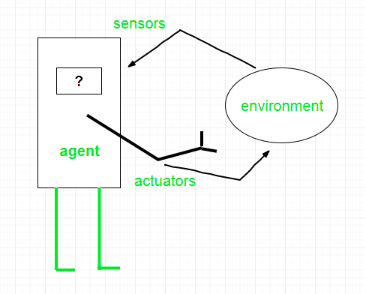

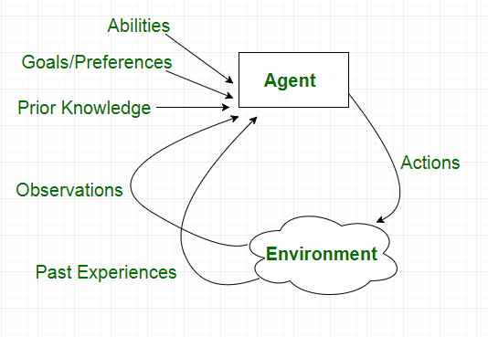

**Types of Agents**

Agents can be grouped into five classes based on their degree of perceived intelligence and capability. All these agents can improve their performance and generate better action over the time. These are given below:

* Simple Reflex Agent
* Model-based reflex agent
* Goal-based agents
* Utility-based agent
* Learning agent

## **1. Simple Reflex agent:**

* The Simple reflex agents are the simplest agents. These agents take decisions on the basis of the **current percepts** and ignore the rest of the percept history.
* These agents only succeed in the fully **observable environment**.
* The Simple reflex agent does not consider any part of percepts history during their decision and action process.
* The Simple reflex agent works on **Condition-action rule,** which means it maps the current state to action. Such as a Room Cleaner agent, it works only if there is dirt in the room.

**Limitations:**

* + They have **very limited intelligence**
  + They do not have knowledge of non-perceptual parts of the current state
  + **Mostly too b**ig to generate and to store.
  + **Not adaptive** to changes in the environment.

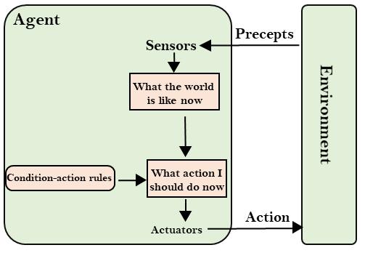

**Examples**

* **Robotic vaccum cleaner**
* **iDraw**

## **2. Model-based reflex agent**

The Model-based agent can work in a **partially observable** environment, and **track the situation**.

* A model-based agent has two important factors:
  + Model: It is knowledge about "how things happen in the world," so it is called a Model-based agent.
  + Internal State: It is a representation of the current state based on percept history.
* These agents have the model, "which is knowledge of the world" and based on the model they perform actions.
* Updating the agent state requires information about:
  + How the world **evolves**
  + How the **agent's action affects** the world.

## 

**Examples**

* **Self-Steering**
* **Mobile Vision**
* **When person walks in lane**

### Lab Task

Develop a simple reflex agent program in Python for the **vacuum-cleaner world problem**. Your agent must defines following things

* States
* Goal State
* Goal Test
* Actions
* Transition Mode
* Path Cost

**Some Pre-defined (Model ) Knowledge for agent**

* **Actions** : Only 0 or 1 where 0 means CLEAN and 1 means DIRTY
* **States :** Your agent have only 3 states (A/B/C)
* **Goal state:** {“A” : 0 , “B” : 0 , “C “: 0}
* **States Sequence :** A , B and C are rooms Connected in following order : A→B and B→C
* **Path Cost :** +1 for every Action (Either from dirt to clean OR moving from one room to another)

**Inputs of Agent**

1. Enter LOCATION (Initial Vaccum placement ) A/B/C in captial letters.
2. Enter Status of Current Location 0/1 accordingly.
3. Vacuum Cleaner senses the status of the other rooms before performing any action, also known as Environment sensing. So Give Status of other rooms as input. (0/1)

**Output of agent**

For each possible initial state(as input ), the program returns a sequence of actions that leads to the goal state, along with the path cost.

**Example Output of 2 State Vaccum World Model**

